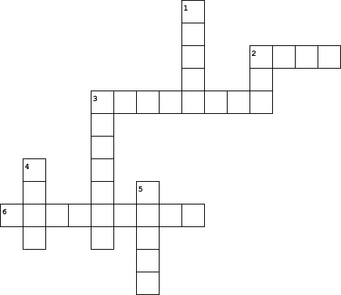

|  |  |  |  |  |  |  |  |  |  |  |  |  |  |  |  |  |  |  |  |  |  |  |
| --- | --- | --- | --- | --- | --- | --- | --- | --- | --- | --- | --- | --- | --- | --- | --- | --- | --- | --- | --- | --- | --- | --- |
| |  |  | | --- | --- | | **Across** | | | **2.** | Fill in the blank: "She was gone and the coldness of it was her final ____" (pg. 58) | | **3.** | The boy's mother uses a "flake of _____" to take her own life (pg. 58) | | **6.** | The man tells his wife before she dies that they are both _____ (pg. 55) | |  | |  |  | | --- | --- | | **Down** | | | **1.** | When the man coughs, he tastes ____ (pg. 54) | | **2.** | The man insists that the boy take a ____ (pg. 70) | | **3.** | The man remembers this old childhood game (pg. 53) | | **4.** | When the stranger confronts the man, what color are his coveralls? (pg. 63) | | **5.** | Fill in the blank: "Death is not a _____" (pg. 57) | |