Name:___________________ Date:______________________

The Road by Cormac McCarthy

Pages 1-25
Worksheet A

Please highlight or make note of any interesting or confusing passages you notice in your reading. If there is anything you would like to make note of for discussion there is space provided at the bottom. The following questions will be used as a guideline for discussion in our next meeting.

1. One of the quotes from the book states, “You forget what you want to remember and you remember what you want to forget.” What does this quote mean to you? Give an example from your own life, if possible.

2. The man shares a memory of him and his uncle at a lake. Why was this memory important to him? Do you have a similar memory that you look back on positively?

3. In the book, the boy paints his facemask with fangs. How old do you think the boy is? What information from the book makes you think this?

4. What is a word that you came across when reading that you did not know the meaning of? Look up the definition and include it below:

a. Transom – a flat surface forming the stern of a boat
b. Declination
c. Collet
d. Marauders - raider
e. Gambreled
f. Languor
g. Opaque – not able to be seen through
h. Pendulum
i. Wonky - crooked
j. Desolate – a very empty area
k. Rotunda
l. Tomb – a large vault, underground with a dead person inside

NOTES:

Name:___________________ Date:______________________

The Road by Cormac McCarthy

Pages 1-25
Worksheet B

Please highlight or make note of any interesting or confusing passages you notice in your reading. If there is anything you would like to make note of for discussion there is space provided at the bottom. The following questions will be used as a guideline for discussion in our next meeting.

1. One of the quotes from the book states, “You forget what you want to remember and you remember what you want to forget.” How much do you agree with this?

Disagree Agree

1 2 3 4 5 6 7 8 9 10

2. The man shares a memory of him and his uncle at a lake. Why was this childhood memory important to him?
a. It was a perfect day.
b. It was a bad day.
c. It was a strange day.
d. It was a sad day.

3. In the book, the boy paints his facemask with fangs. How old do you think the boy is?
a. 18 years old
b. 12 years old
c. 5 years old
d. 2 years old

4. Were there any words you didn’t know when you heard/read them? yes/ no

Circle any words that you came across when reading that you did not know the meaning of. (you can circle more than one)
a. Transom
b. Declination
c. Collet
d. Marauders
e. Gambreled
f. Languor
g. Opaque
h. Pendulum
i. Wonky
j. Desolate
k. Rotunda
l. Tomb

NOTES:

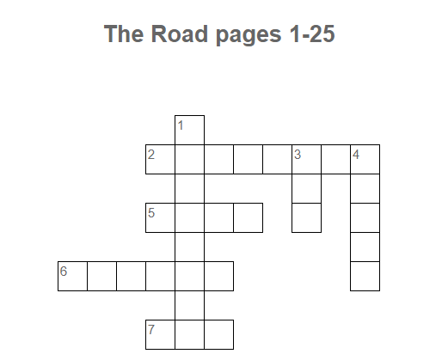
Across | Down
2 What does the man find in the closet of the farmhouse? (p.22)  5 What is the man pushing? (p. 5)  6 What does the man carry for protection? (p.5)  7 The man and boy visit the house where the _____ grew up. (p. 25) | 1 What drink does the man give the boy? (p. 23)  3 What do the man and boy find at the gas station? (p.7)  4 Which direction are the man and the boy traveling? (p. 4)

