The Thursday Murder Club Chapter 1-5 Crossword
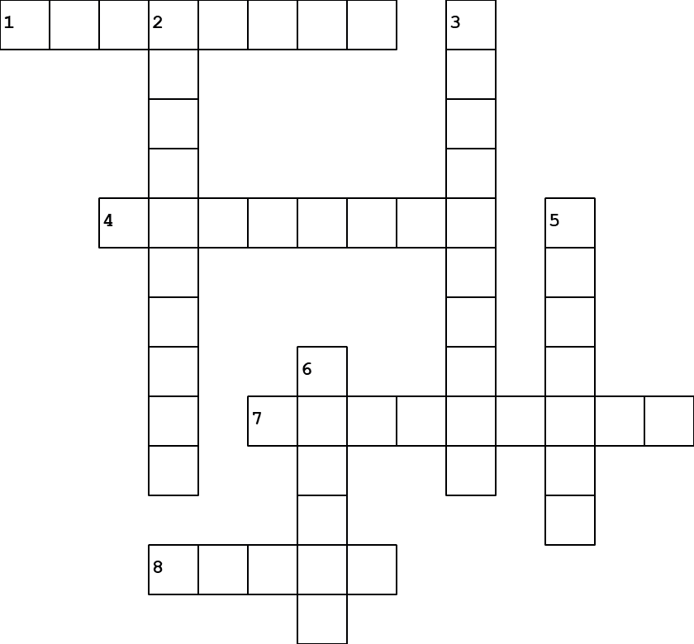
Across
1. The day the murder club happens (page 8)
4. Not the gas board anymore, it's ____ (Page 10)
7. Ian listens to a motivational ______ (page 26)
8. The Jigsaw room is booked under "Japanese ____: A Discussion" (Page 21)

Down
2. Ian Ventham's car (page 24)
3. The room used for Thursday Murder Club meetings (Page 19)
5. The nursing home for the village (page 17)
6. Coopers Chase is Britain's First _____ Retirement Village (Page 15)

