The Thursday Murder Club Chapters 70-79 (pgs. 215-241)
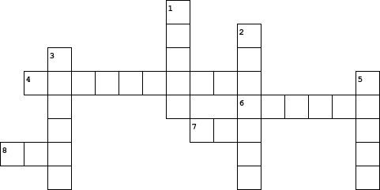

  Across
  4. | Joyce and Elizabeth are headed to ______ (p. 241)
  6. | The nickname Austin calls Elizabeth in the graveyard (p. 219)
  7. | Elizabeth suggests that they go back to Joyces for a cup of ____ (p. 221)
  8. | Austin was sure that the body belonged to a ______ (p. 222)
  Down
  1. | The body was believed to have been buried about ______ years ago (p. 227)
  2. | Donna tells Elizabeth that father Mackie was a doctor in _____ (p. 235)
  3. | The name of the man who took the photo is Turkish _____ (p. 217)
  5. | Location of the gunshot wound (p. 226)

