The Thursday Murder Club Chapters 112-End Crossword
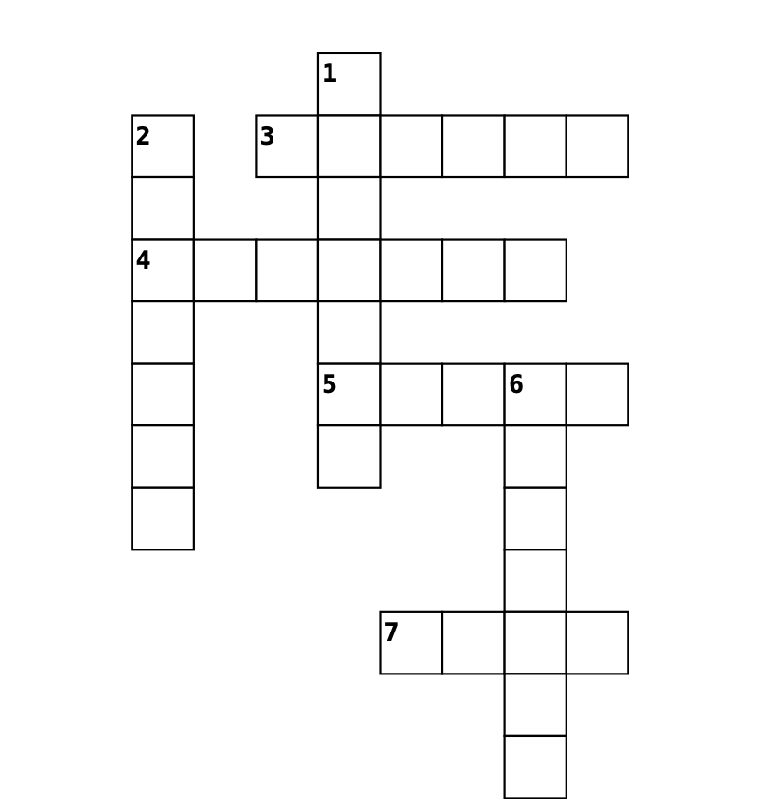
Down
1. “I see the choice you made, to deliver your own ________.” (334)
2. In Chapter 113, Chris receives an email from _________ Associates.
6. In Chapter 114, who does Bogdan confide in about killing Tony Curran?
Across
3. What crime did Penny commit in the line of duty? (pg. 335)
4. "And once John knew, he had to _______ her." (pg. 346)
5. What game were Stephen and Bogdan playing in Chapter 114?
7. Who killed Ian Ventham? (pg. 346)

