August 6, 2026
Dear Aphasia Group Participants and Families,

The fall semester is approaching, and aphasia groups will be back in session! As a reminder, this is why aphasia groups are so important:

- Social Networks. Connecting with other people is critical for quality of life and for longevity. It also helps the rehabilitation process!
- For perspective. You may see people in group who are struggling more than you and then there are those who seem to have almost fully recovered! This perspective can change your outlook. Aphasia group members learn a lot from each other—from the way they handle family gatherings to strategies on how to start reading again.
- Language Practice. You cannot improve if you are not practicing regularly. Speech therapy is not enough. You need to USE IT to IMPROVE it.

In addition to this, you are helping us train our student clinicians to be incredible speech and language pathologists. You are vitally important to their understanding of all the different ways aphasia can present, and how critical it is to prioritize the goals of the client in treatment planning.

Thank you to all of you who are already doing this!!! And we welcome those of you who are joining for the first time!

For those who don’t know me, my name is Jen Mozeiko. In addition to being a licensed speech and language pathologist (SLP), I’m a professor at UConn. I teach and I do research focused on improving treatment post stroke. I have been working with the book clubs and language support groups at UConn for 20 years.

Usually, we correspond with email so please be sure I have your correct email address! However, once a year we go old school and you get a physical letter with all of the important details for the year, as well as a parking pass. There is also lot of good information on our website, so take a look there as well: https://aphasia-rehab.slhs.uconn.edu/. It discusses our research and the different aphasia groups we offer. In short, we offer two options:

- Language Support Groups- here the focus is on language and “total communication” practice. All group members will be encouraged to participate. We have many group members who have been attending for several years. They are incredibly welcoming and helpful to our newer folks.

- Book Clubs- here we challenge you just a little more. We expect people to do a little reading (or listening to an audio book) and a little writing (based on ability) each day. The conversation is focused heavily on the book but if everyone is engaged and interested, we allow for diversions. Two of our book clubs take place on the Storrs campus. One of them takes place virtually. Our online book club fills up quickly so you must reserve your spot if you are interested in this option. We cap all groups at 10 to maximize opportunities for conversation.

All groups are run by our first-year graduate student clinicians. Aphasia group members and their families are instrumental in their educational experience!

DONATIONS

We offer the aphasia groups free of charge but to help us cover the cost of materials and technology, many of our group members choose to make a donation of $25 each semester. If you choose to do so, you may bring cash or a check. If it’s the latter, please follow these instructions, exactly: Make the check out to the UConn Foundation (not to me) with “6333540-aphasia programming” in the memo line. Checks can be mailed to the following address: Dr. Jen Mozeiko, 2 Alethia Dr., Unit 1085, Storrs, CT 06269.

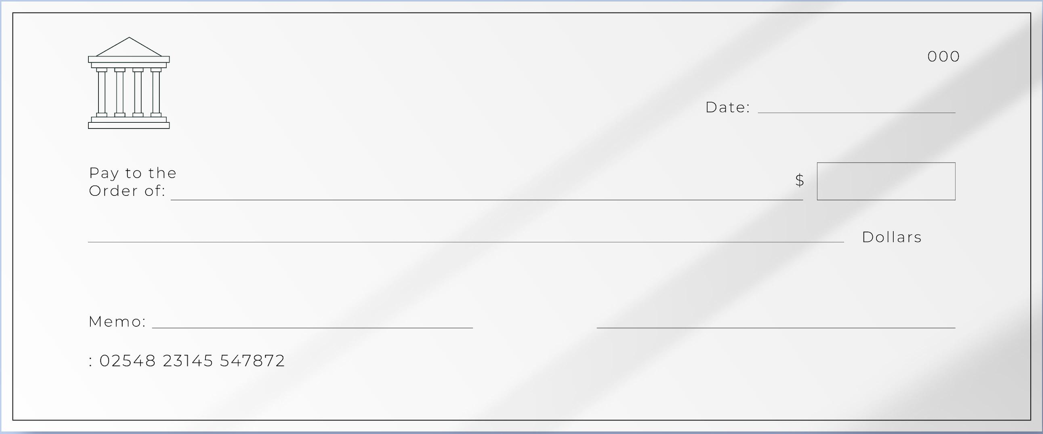
6333540-aphasia programming
UConn Foundation

You can also donate online by following this link which I will send via email: https://giving.uconn.edu/campaigns/60852/donations/new?designation=aphasiaprogramfund

MORE DETAILS
All groups meet on Fridays in one of the time slots below. Our first meeting will be on Friday, September 11th. For more information, check the Aphasia Rehab Lab website:
https://aphasia-rehab.slhs.uconn.edu/uconn-aphasia-group/

Location and parking
In person groups will take place in the Human Development Center (HDC) on the 2nd floor. An elevator is available for those who need it. The address is 6 Alethia Drive, Storrs, CT 06269. Traveling on Alethia Drive please follow signs for “Clinics” and park in the large circular parking lot. Please use the parking pass enclosed to park in the circle or behind the Philips Building.

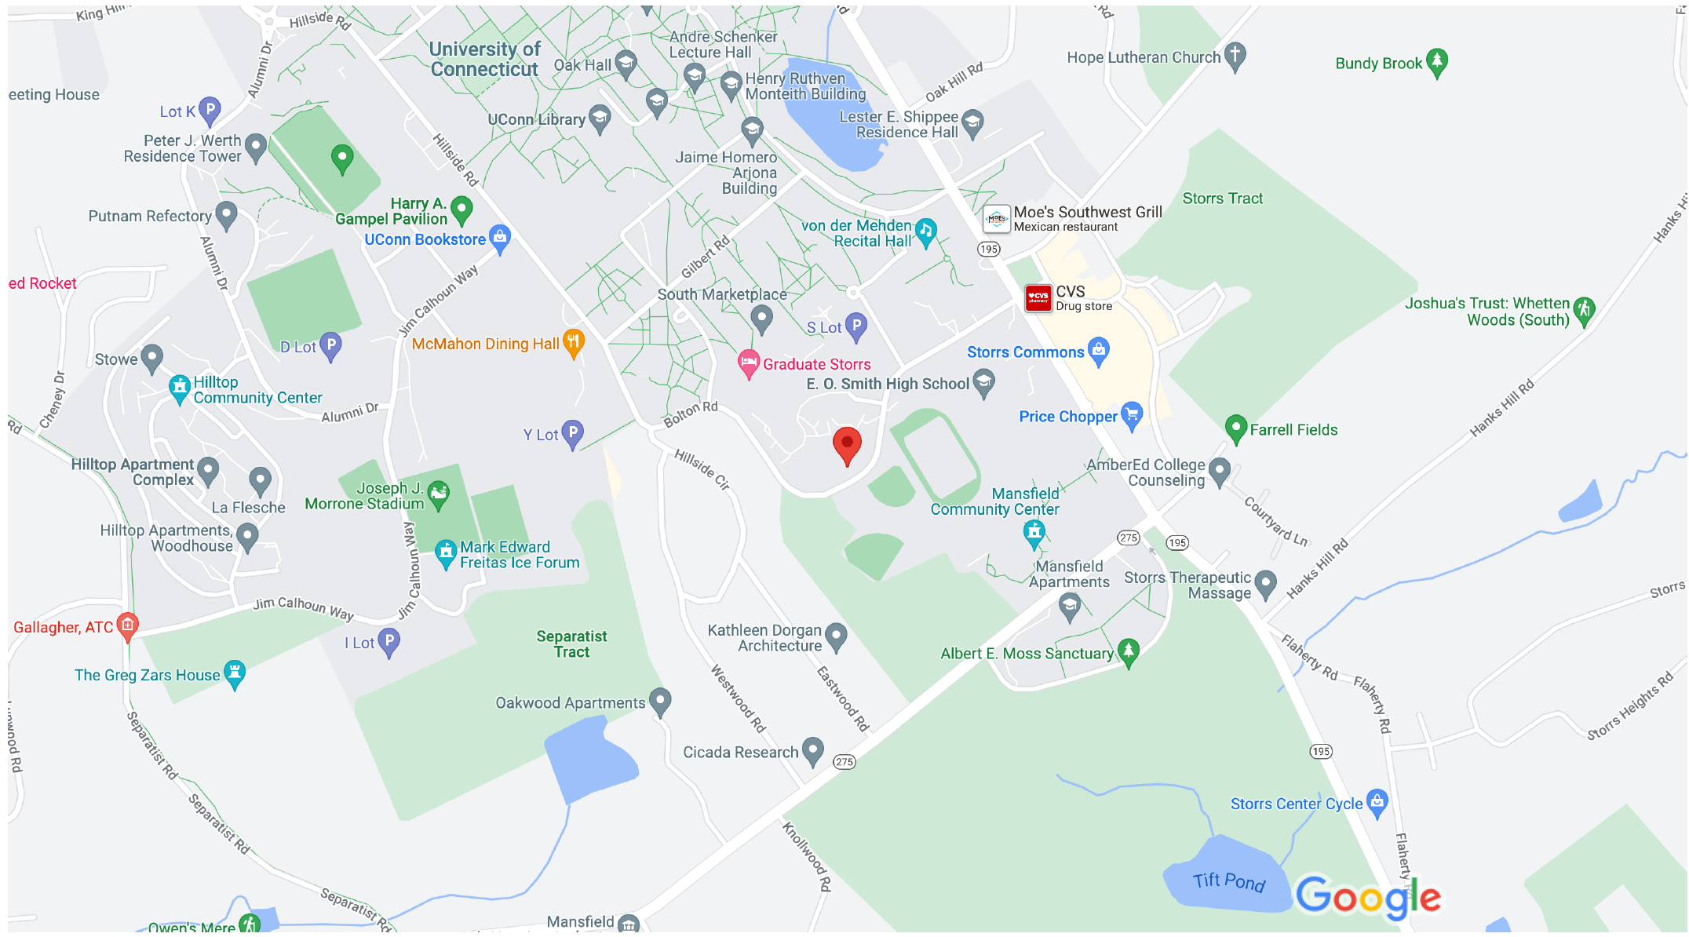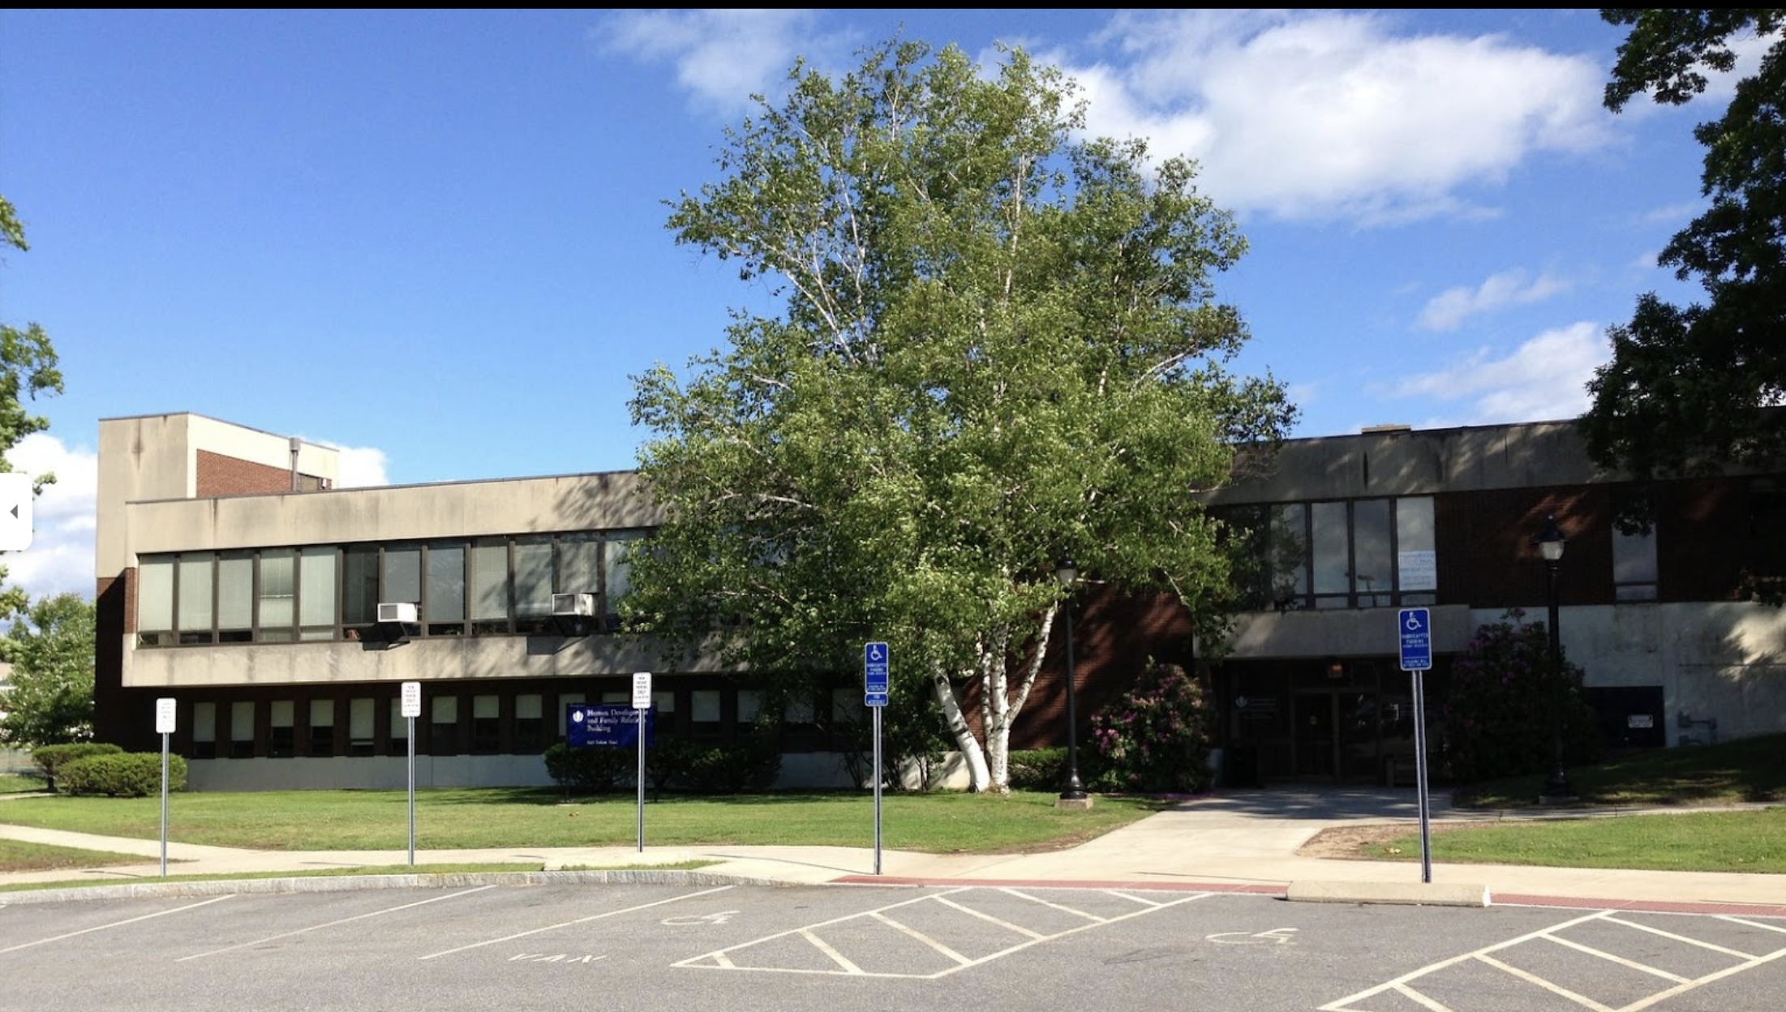

Language Groups (11:00-12:30)- These groups are for anyone with aphasia and includes people who have quite limited receptive and expressive language as well as those with just minor language difficulties. Sometimes new members ask if their family member can sit through the group the first time. That’s fine, but we will discourage this going forward, as gaining independence and comfortability with aphasia is one of our main objectives. We pay special attention to our newest members!

Aphasia Book Clubs (1:00-2:30)- These groups are for those who can read (or listen to) a short novel and understand it. Some people use an audiobook along with the reading or just use the audiobook alone. Any of this is fine. Books provide great content to talk about, and we center on themes from the book in our discussion. Conversation is the goal, and in this group, we also provide various levels of homework to get people thinking about the discussions beforehand. We understand that everyone has different reading preferences. If we choose a book that is not of interest, please come to the group anyway, knowing that the conversation practice is the most important part of this! Online groups take place concurrently and your slot must be reserved ahead of time.

This semester we will be reading One in a Million Boy. You should not begin reading before you arrive. On our first day, we will catch up with each other, go over the calendar for the year and your assignments. We will have a copy of the book to give you on that day, so there is no need to purchase it.

Family and Friends Group– In this group, we acknowledge how stroke and aphasia have impacted friends and family. Care partners and others come together to discuss the changes, challenges, and helpful tips about living with someone with aphasia. Groups are run by seasoned care partners while Dr. Mozeiko and students contribute by debunking some myths and answering questions you have about recovery and communication. Timing overlaps with language groups (11-12:30)

RECAP
- You choose the group you would like to attend and just come! RSVP if you can but you’re welcome even if you haven’t! Questions? Email, text, or call me!
- If you would like to attend the online book club, you must RSVP. We will send you instructions on how to join.
- If you are considering joining the group for friends, family and caregivers, please email me!
- Bring cash or mail a check for $25 (made out to UConn Foundation) on the first day if you plan to contribute to aphasia programming. This helps to cover snacks, books, materials, activities, guest speakers, and our annual winter celebration. Thank you!

IMPORTANT DATES TO REMEMBER
- September 11th- Group Begins
- October 2nd – No Meeting, students attending an interprofessional training day
- November 27th – No Meeting, Thanksgiving Break

December 11th – End of Semester Brunch and Workshop! (TIME TBD!)

Please note: Aphasia groups are not run by the UConn speech and hearing clinic. Please do not call the front desk with questions. Instead, please call or text me directly, and I or one of my research assistants will return your call: 860-420-9828

Sincerely,
Contact Jen with any questions and to RSVP!

Email:Jennifer.mozeiko@uconn.edu
Phone/Text: 860-420-9828
Website: https://aphasia-rehab.slhs.uconn.edu

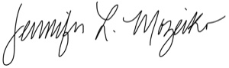
Jennifer Mozeiko, PhD, CCC-SLP
Associate Professor
Director, Aphasia Rehab Lab

